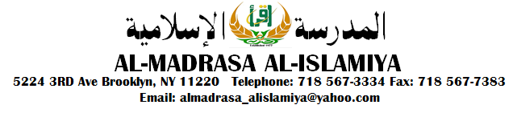

Recreation & Trip Permission
Form

Your child’s class will have scheduled recreation. Unscheduled recreation takes place occasionally, particularly in warm weather. Throughout the year there are class trips.

Recreation is Generally at One of the Following Sites

- Bay Ridge on Shore Road, Prospect Park, & Sunset Park.
- Brooklyn Public Library.
- Brooklyn Botanical Gardens.
- Melody Lanes (Bowling).
- Playground on 2nd Avenue & 55th Street.
- Al-Madrasa Al-Islamiya/Masjid Basement.
- Local site at school’s discretion.
- Brooklyn Bridge Park.
- Owl’s Head Park.
- Bush Terminal Park.

Classes generally travel by school bus. Occasionally, mass transit is used, students are allowed to bring sneakers to school to wear on recreation day.

Please Return this Permission Slip to the School Office

I give My Child __________________________ in Class ____________ Permission to participate in Trip & Recreation for the School Year of 16/17.

I Give My Full Permission for My Child To Receive Medical Treatment. In Case of an Emergency Please Contact Me at Telephone Number: _______________ An Additional Telephone Number is: __________________________________

Parent’s Signature: ________________________________________________

School Administration

